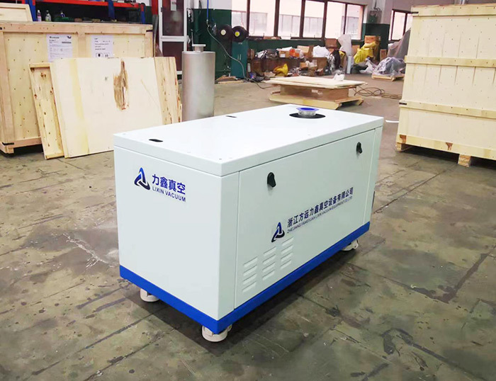

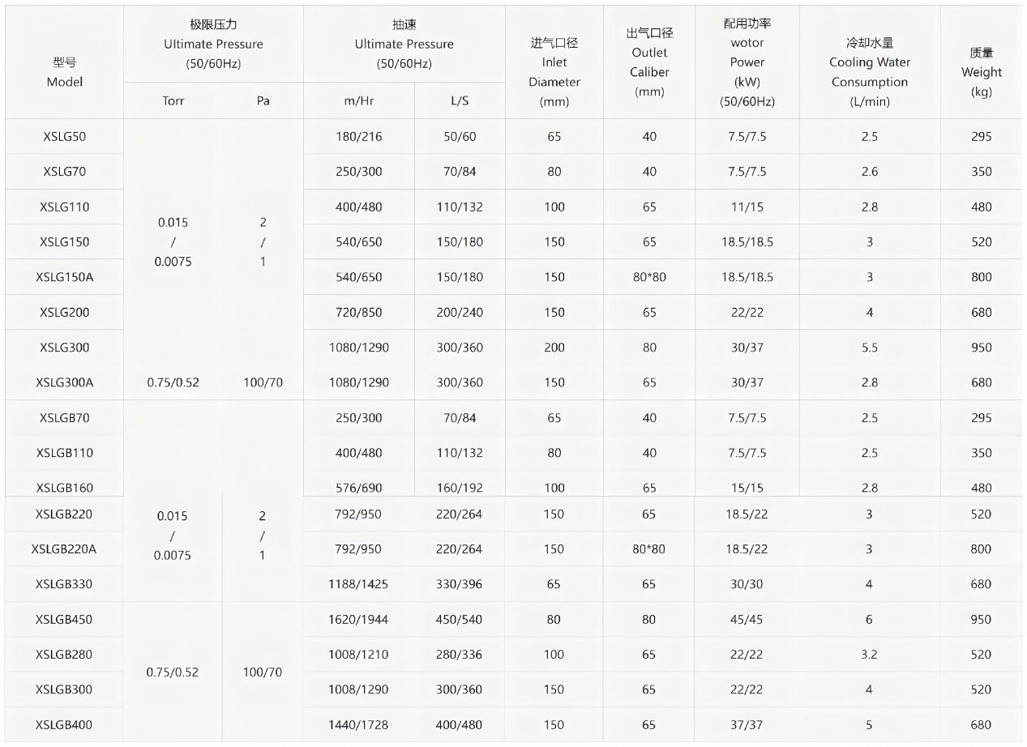

Characteristics

Due to market demand, the screw vacuum pump is equipped with a movable frame and a box-shaped housing. The equipment has the following advantages: The pump is equipped with a movable frame, which enables single-person operation for equipment transfer and fixation, and is suitable for multi-point operation.

The pump is enclosed in a box-shaped housing, which has strong environmental adaptability and a neat and beautiful appearance.

The power supply, cooling water path, gas source gas path, etc. are concentrated on the side panel, making it convenient for customers to disassemble and install.

The pump can be optionally equipped with frequency control, water-cooled motor, temperature monitoring, flow monitoring, etc., with high stability.

The pump can be optionally equipped with PLC control, wireless Wifi and Modbus standard communication protocols, facilitating mobile data exchange.

